**CISCO Packet Tracer Lab-Assignment-3**

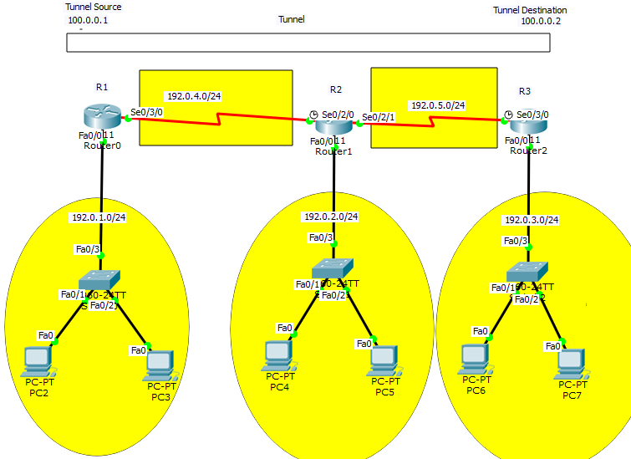

**Figure 2**

Q2) Above network has 5 sub networks these are 192.0.1.0/24, 192.0.2.0/24, 192.0.3.0/24, 192.0.4.0, and 192.0.5.0. Three routers are attach using serial DTE.

1. Assign IP addresses, sub-net masks, and default gateway to all the interfaces.
2. Check your network by pinging to all the IPs within the same sub-net.
3. Now check if you are able to ping an IP address of different sub-net (that is not directly attached to router).
4. Configure statically routing entries in both the routers and try to ping an IP address of the different sub-net.
5. Configure router dynamically using RIP protocol. First, you have to remove previous routing entries.
6. Run tracert (Trace route) command using cmd from PC7 using IP of se0/3/0 interface (the name of interface may be different in your scenario, so be careful). Observe the ip of interfaces shown as a result of command execution.
7. Establish a tunnel between R1 and R3 as shown in Figure 2.
8. Run tracert again form PC7 using IP of tunnel (in this scenario it is 100.0.0.1). Observe the difference in the result between 6th question and this.
9. Save your running config file of R1, R2, and R3 in files name as yourName_yourRollNo_Ass2_RunConf_R1.txt, yourName_yourRollNo_Ass2_RunConf_R2.txt,

and yourName_yourRollNo_Ass2_RunConf_R3.txt.

If you are using console and enable password then specify them in a README file

1. Upload above mentioned files along with .pkt file on the moodle website before deadline.

NOTE- First of all, try to solve these questions your self don’t bother about answers.